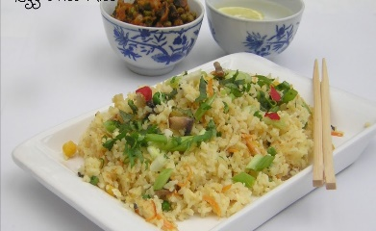

Egg fried rice

Ingredients

1 packet microwavable rice

4 spring onions chopped

2 mushrooms chopped

1 red pepper diced

2 eggs beaten

1 tablespoon chilli jam or sweet chilli sauce

Salt and pepper

Splash water

Optional- diced cooked chicken, sliced cooked sausage, Quorn pieces, and tofu.

Method

In a large pan heat 1 tablespoon of oil and fry the spring onions

Add the peppers, mushrooms and chilli jam

Pour in the rice and mix well add a little water and cook for 2 minutes

Make a well and push all the ingredients to the edge of the pan

Pour in the beaten eggs and cook until scrambled

Mix together and add the cooked chicken and coo foe another minute until heated through

Spoon in to a bowl and enjoy